**Project Phase 2**

Team Name: AutoPed   
Team Number: 40   
Members: Vihaan Patel, Naman Gandhi, Ayush Shejwal, Gautam Mehta, Swar Khatav

# [A] Use Cases and Use Case Diagram

|  |  |
| --- | --- |
| User login | |
| Actors | Nurse, Doctor, Patient |
| Description | The actor can select the applicable role and log in to the system |
| Data | Username/email/phone, password |
| Stimulus | Returning user wants to access the system as per their role |
| Response | Take the current user to their respective portal as per their role |
| Comments |  |

|  |  |
| --- | --- |
| Create user account | |
| Actors | Patient, Nurse, Doctor, System Administrator |
| Description | Users can create a new account by selecting the account type (nurse/doctor/patient) |
| Data | First name, last name, birth date, username/email/phone, pharmacy |
| Stimulus | A new user wants to access/join the system as a patient, nurse, or doctor |
| Response | A new account with basic details is created in the database by the system administrator |
| Comments |  |

|  |  |
| --- | --- |
| Register new patient | |
| Actors | Nurse |
| Description | The nurse registers a new patient if they have not already created a user account themselves |
| Data | First name, last name, birth date, username/email/phone, pharmacy |
| Stimulus | Patient without an existing user account arrives at the clinic |
| Response | A new account with basic details is created in the database by the system administrator |
| Comments |  |

|  |  |
| --- | --- |
| Patient check-in | |
| Actors | Nurse |
| Description | The nurse accesses a patient’s account (if it exists) to either record vitals or health history |
| Data | First name, last name, birth date |
| Stimulus | The nurse receives a patient with an existing user account to proceed with recording prerequisite data |
| Response | It gives the nurse the option to record the patient’s current vitals and modify health history if needed |
| Comments |  |

|  |  |
| --- | --- |
| Record vitals | |
| Actors | Nurse, System Administrator |
| Description | The nurse records the patient’s current vitals |
| Data | Vitals |
| Stimulus | The patient is checked in by the nurse |
| Response | Save recorded vitals in the database managed by the system administrator |
| Comments |  |

|  |  |
| --- | --- |
| Record health history | |
| Actors | Nurse, System Administrator |
| Description | Nurse records/modifies patient’s health history |
| Data | Health history |
| Stimulus | The patient is checked in by the nurse |
| Response | Save recorded/modified health history in the database managed by the system administrator. |
| Comments |  |

|  |  |
| --- | --- |
| View patient info | |
| Actors | Nurse, Doctor |
| Description | The nurse and the doctor can use the patient’s name to access their information, health history, visit summary, and contact. |
| Data | Patient name, vitals, health history, visit summary, latest message |
| Stimulus | The nurse or doctor wants to view a specific patient’s information or messages. |
| Response | Display overview of all patient-related information and access to messaging portal to connect with patients. |
| Comments |  |

|  |  |
| --- | --- |
| Message patients | |
| Actors | Nurse, Doctor, System Administrator |
| Description | The nurse and the doctor can view messages sent directly from the patients and reply to them |
| Data | Patient name, message |
| Stimulus | The nurse or the doctor accesses the messaging portal while viewing the patient's information |
| Response | Send a message/reply to the respective patient |
| Comments |  |

|  |  |
| --- | --- |
| Examine patient | |
| Actors | Doctor |
| Description | The doctor receives a patient after completing a prerequisite check with the nurse and proceeds to perform an examination |
| Data | Doctor’s notes |
| Stimulus | The patient with recorded vitals and health history received by the doctor |
| Response | Record examination information |
| Comments |  |

|  |  |
| --- | --- |
| Prescribe medications | |
| Actors | Doctor |
| Description | The doctor can prescribe medications to be sent to the pharmacy listed in the patient’s account |
| Data | Patient visit, prescription, pharmacy |
| Stimulus | The doctor completes a medical examination |
| Response | Record prescription data |
| Comments |  |

|  |  |
| --- | --- |
| Record examination data | |
| Actors | Doctor, System Administrator |
| Description | On completion of the doctor’s procedure, the doctor’s findings and prescribed medications are saved in the database |
| Data | Doctor’s note, patient visit, prescription, pharmacy |
| Stimulus | The doctor completes a medical examination and prescribes medications |
| Response | Save examination data to the database managed by the system administrator |
| Comments |  |

|  |  |
| --- | --- |
| Edit account info | |
| Actors | Patient, System Administrator |
| Description | The patient can access and edit their account information |
| Data | First name, last name, birth date, phone/email, password |
| Stimulus | Patient wishes to change their information or password |
| Response | Save modified information to the database managed by the system administrator |
| Comments |  |

|  |  |
| --- | --- |
| View summary of previous visits | |
| Actors | Patient |
| Description | The patient can view a summary of all their previous visits at the clinic in a list view |
| Data | Patient visit, Doctor’s note, Prescription |
| Stimulus | The patient wishes to refer to information from their previous visit |
| Response | Display all information related to the patient’s previous visits |
| Comments |  |

|  |  |
| --- | --- |
| Contact doctor/nurse | |
| Actors | Patient, System Administrator |
| Description | The patient can message the doctor or the nurse directly |
| Data | Patient name, message |
| Stimulus | The patient accesses the messaging portal on their page |
| Response | Send a message/reply to the doctor/nurse portal |
| Comments |  |

# [B] Object Identification and CRC

Objects Identified are:

1. User

The User object represents individuals interacting with the system. Users can have different roles such as Nurse, Doctor, or Patient. They utilize the system for various purposes including logging in, creating accounts, accessing patient information, and communicating with healthcare providers.

2. Nurse

The Nurse object represents nursing staff within the healthcare system. Nurses perform tasks such as registering patients, recording vitals, updating health histories, and communicating with patients and other healthcare providers.

3. Doctor

The Doctor object represents medical professionals within the healthcare system responsible for diagnosing and treating patients. Doctors perform tasks such as examining patients, prescribing medications, recording medical notes, and communicating with patients and other healthcare providers.

4. Patient

The Patient object represents individuals receiving medical care within the healthcare system. Patients interact with the system to check in for appointments, view their medical records, communicate with healthcare providers, and manage their health information.

5. System Administrator

The System Administrator object represents individuals responsible for managing and maintaining the healthcare system. System administrators oversee user accounts, system configurations, database operations, and ensure the overall functionality and security of the platform.

6. Account:

The Account object represents the user's credentials and access privileges within the healthcare system. Accounts are created for each user, allowing them to log in and access specific functionalities based on their roles (e.g., Nurse, Doctor, Patient).

7. Health Record

The Health Record object contains comprehensive medical information and history for each patient within the healthcare system. Health records include data such as vitals, health history, doctor's notes, prescriptions, and other relevant medical information.

8. Messaging Portal

The Messaging Portal object provides a communication platform within the healthcare system, allowing users (e.g., Nurses, Doctors, Patients) to exchange messages securely. The portal facilitates communication between patients and healthcare providers, enabling timely interaction and collaboration.

9. Pharmacy:

The Pharmacy object represents establishments where medications are dispensed to patients based on prescriptions provided by healthcare providers. Pharmacies may be integrated into the healthcare system, allowing seamless transmission of prescriptions and medication management.

10. Visit

The Visit object represents individual instances of patients' visits to healthcare facilities for medical appointments or consultations. Each visit includes relevant information such as the visit date, doctor's notes, prescriptions, and other clinical data.

|  |  |
| --- | --- |
| User | |
| Represents individuals interacting with the healthcare system. Users can log in, create accounts, manage account information, view patient information, and communicate with healthcare providers and other users. | |
| Responsibilities | Collaborators |
| -Log In  -Create Account  -Edit Account Information  -View Patient Info  -Message Patients  -Contact doctor/nurse | -Nurse  -Doctor  -Patient  -System Administrator |

|  |  |
| --- | --- |
| Nurse | |
| Represents nursing staff responsible for patient care tasks within the healthcare system. Nurses register new patients, record patient vitals and health history, check-in patients, and collaborate with doctors and patients for effective care delivery. | |
| Responsibilities | Collaborators |
| -Register New Patient  -Patient Check-In  -Record Vitals  -Record Health History  -View Patient Info  -Message Patients  -Contact doctor | -Patient  -Doctor  -System Administrator |

|  |  |
| --- | --- |
| Doctor | |
| Represents medical professionals responsible for diagnosing and treating patients within the healthcare system. Doctors examine patients, prescribe medications, record examination data, and collaborate with nurses and patients for comprehensive patient care. | |
| Responsibilities | Collaborators |
| -Examine Patient  -Prescribe Medications  -Record Examination Data  -View Patient Info  -Message Patients  -Contact Nurse | -Patient  -Nurse |

|  |  |
| --- | --- |
| Patient | |
| Represents individuals receiving medical care within the healthcare system. Patients can view summaries of previous visits, contact healthcare providers, access personal health information, and communicate with nurses and doctors for inquiries or appointments. | |
| Responsibilities | Collaborators |
| -View Summary of previous visits  -Contact Doctor/Nurse  -View Patient Info  -Book Appointment | -Nurse  -Doctor  -System |

|  |  |
| --- | --- |
| System Administrator | |
| Represents individuals responsible for managing and maintaining the healthcare system. System administrators manage user accounts, system configurations, and database operations to ensure the system's functionality and security. | |
| Responsibilities | Collaborators |
| -Manage user accounts  -Manage system configurations  -Manage Database operations | -User  -Nurse  -System Administrator |

|  |  |
| --- | --- |
| Account | |
| Represents user credentials and access privileges within the healthcare system. Accounts authenticate users and authorize access to system functionalities based on user roles and permissions. | |
| Responsibilities | Collaborators |
| -Authenticate Users  -Authorize access to functionalities | -User  -System Administrator |

|  |  |
| --- | --- |
| Health Record | |
| Represents comprehensive medical records for patients within the healthcare system. Health Records store and manage medical data, providing access to relevant information for healthcare providers and patients. | |
| Responsibilities | Collaborators |
| -Store medical Data  -Provide Access to Data | -System Administrator |

|  |  |
| --- | --- |
| Messaging Portal | |
| Represents a communication platform within the healthcare system. The Messaging Portal facilitates communication among users, enabling messaging between patients, nurses, and doctors for inquiries, appointments, and updates. | |
| Responsibilities | Collaborators |
| -Facilitate Communication  -Manage Messages | -User  -Nurse |

|  |  |
| --- | --- |
| Pharmacy | |
| Represents establishments where medications are dispensed to patients. Pharmacies receive and process prescriptions from doctors, dispensing medications to patients as part of their treatment plans. | |
| Responsibilities | Collaborators |
| -Deliver Medications  -Receive and Process Prescriptions | -System Administrator  -Patient |

# [C] Class Diagram

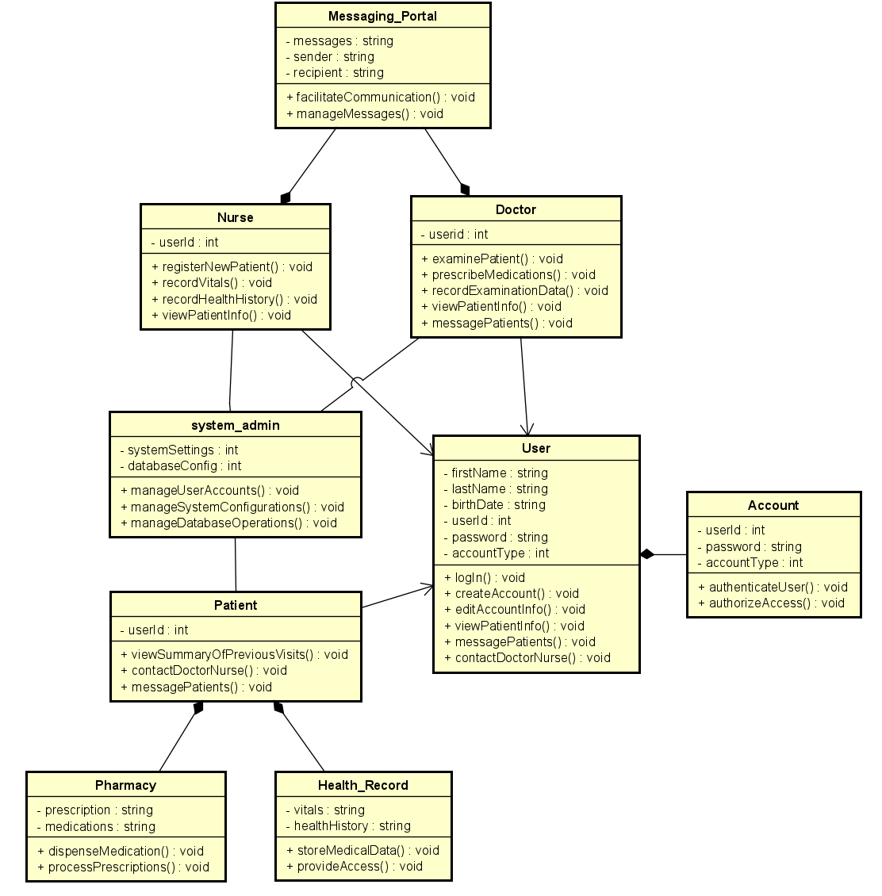

# [D] Test Plan for Functional Testing

Use Case 1: User Login

* **Test Case 1.1: Valid User Login**
  + **Description:** Verify that a user can successfully log in with valid credentials.
  + **Test Steps:**
    1. Enter valid username/email/phone and password.
    2. Click on the login button.
  + **Expected Result:** User is directed to their respective portal.

Use Case 2: Create User Account

* **Test Case 2.1: Create Patient Account**
  + **Description:** Verify that a patient can create a new account successfully.
  + **Test Steps:**
    1. Select "Patient" as the account type.
    2. Fill in all required fields with valid information.
    3. Click on the create account button.
  + **Expected Result:** Patient account is created in the database.

Use Case 3: Register New Patient

* **Test Case 3.1: Register New Patient**
  + **Description:** Verify that a nurse can register a new patient successfully.
  + **Test Steps:**
    1. Enter patient details including first name, last name, birth date, and contact information.
    2. Click on the register button.
  + **Expected Result:** New patient is registered in the system.

Use Case 4: Patient Check-In

* **Test Case 4.1: Check-In Existing Patient**
  + **Description:** Verify that a nurse can check in an existing patient successfully.
  + **Test Steps:**
    1. Search for the existing patient by name or ID.
    2. Record vitals and modify health history if necessary.
    3. Click on the check-in button.
  + **Expected Result:** Patient is checked in, and relevant data is updated.

Use Case 5: Record Vitals

* **Test Case 5.1: Record Patient Vitals**
  + **Description:** Verify that a nurse can record patient vitals successfully.
  + **Test Steps:**
    1. Access the record vitals feature.
    2. Enter the patient's vitals.
    3. Save the recorded vitals.
  + **Expected Result:** Patient vitals are saved in the database.

Use Case 6: Record Health History

* **Test Case 6.1: Record Patient Health History**
  + **Description:** Verify that a nurse can record a patient's health history successfully.
  + **Test Steps:**
    1. Access the record health history feature.
    2. Record or modify the patient's health history.
    3. Save the recorded health history.
  + **Expected Result:** Patient's health history is updated in the system.

Use Case 7: View Patient Info

* **Test Case 7.1: View Patient Information**
  + **Description:** Verify that a nurse or doctor can view patient information successfully.
  + **Test Steps:**
    1. Search for the patient by name or ID.
    2. Access patient information, including vitals, health history, and visit summary.
  + **Expected Result:** Patient information is displayed accurately.

Use Case 8: Message Patients

* **Test Case 8.1: Send Message to Patient**
  + **Description:** Verify that a nurse or doctor can send a message to a patient successfully.
  + **Test Steps:**
    1. Access the messaging portal.
    2. Select the patient to message.
    3. Compose and send a message.
  + **Expected Result:** Message is sent to the patient without any errors.

Use Case 9: Examine Patient

* **Test Case 9.1: Doctor Examines Patient**
  + **Description:** Verify that a doctor can perform an examination on a patient successfully.
  + **Test Steps:**
    1. Access the examination section.
    2. Select the patient to examine.
    3. Perform the examination and record findings.
  + **Expected Result:** Examination data is recorded accurately.

Use Case 10: Prescribe Medications

* **Test Case 10.1: Doctor Prescribes Medications**
  + **Description:** Verify that a doctor can prescribe medications to a patient successfully.
  + **Test Steps:**
    1. Access the prescription section.
    2. Select the patient to prescribe medications.
    3. Enter prescription details and send to the pharmacy.
  + **Expected Result:** Prescription is recorded and sent to the pharmacy correctly.

Use Case 11: Record Examination Data

* **Test Case 11.1: Record Examination Data**
  + **Description:** Verify that examination data is saved in the database after a doctor completes an examination.
  + **Test Steps:**
    1. Complete the medical examination.
    2. Record examination findings and prescribed medications.
    3. Save the examination data.
  + **Expected Result:** Examination data is saved accurately in the system.

# [E] Link to video

[video1892799320.mp4](https://arizonastateu-my.sharepoint.com/:v:/g/personal/vpatel69_sundevils_asu_edu/EZ8iUz79K8dHjN1ujxVwS80B8k4hL1cJ25Fymh4fBoahJA?nav=eyJyZWZlcnJhbEluZm8iOnsicmVmZXJyYWxBcHAiOiJPbmVEcml2ZUZvckJ1c2luZXNzIiwicmVmZXJyYWxBcHBQbGF0Zm9ybSI6IldlYiIsInJlZmVycmFsTW9kZSI6InZpZXciLCJyZWZlcnJhbFZpZXciOiJNeUZpbGVzTGlua0NvcHkifX0&e=SeLase)

# Credit Sheet – Team 40

|  |  |  |  |  |  |
| --- | --- | --- | --- | --- | --- |
| **Member Name** | **Use Cases, Use Case Diagram** | **Object Identification and CRC** | **Class Diagram** | **Test Plan and functional testing** | **Prototyping code** |
| Vihaan Patel | 20% | 20% | 20% | 20% | 20% |
| Naman Gandhi | 20% | 20% | 20% | 20% | 20% |
| Ayush Shejwal | 20% | 20% | 20% | 20% | 20% |
| Gautam Mehta | 20% | 20% | 20% | 20% | 20% |
| Swar Khatav | 20% | 20% | 20% | 20% | 20% |